**Phase 3: Data Modeling & Relationships**

**Standard & Custom Objects**

Setup → Object Manager → Select *Standard Objects* (Student, Contact, Account, Application).  
Setup → Object Manager → New Custom Object → Fill *Label, Plural Label, Record Name, Data Type*.

**Fields**  
Setup → Object Manager → Select Object (e.g., Student) → Fields & Relationships → New Field → Select *Data Type (Text, Number, Lookup, etc.)*.

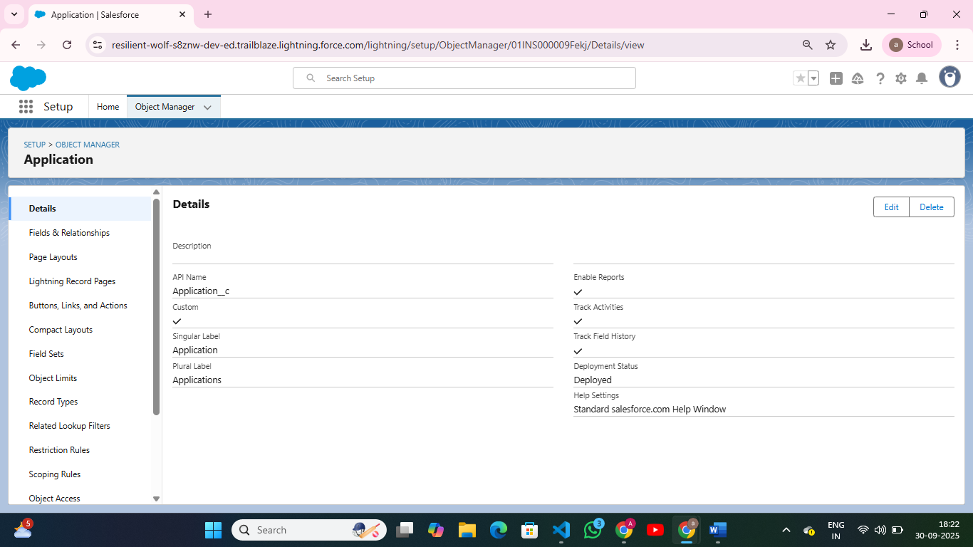

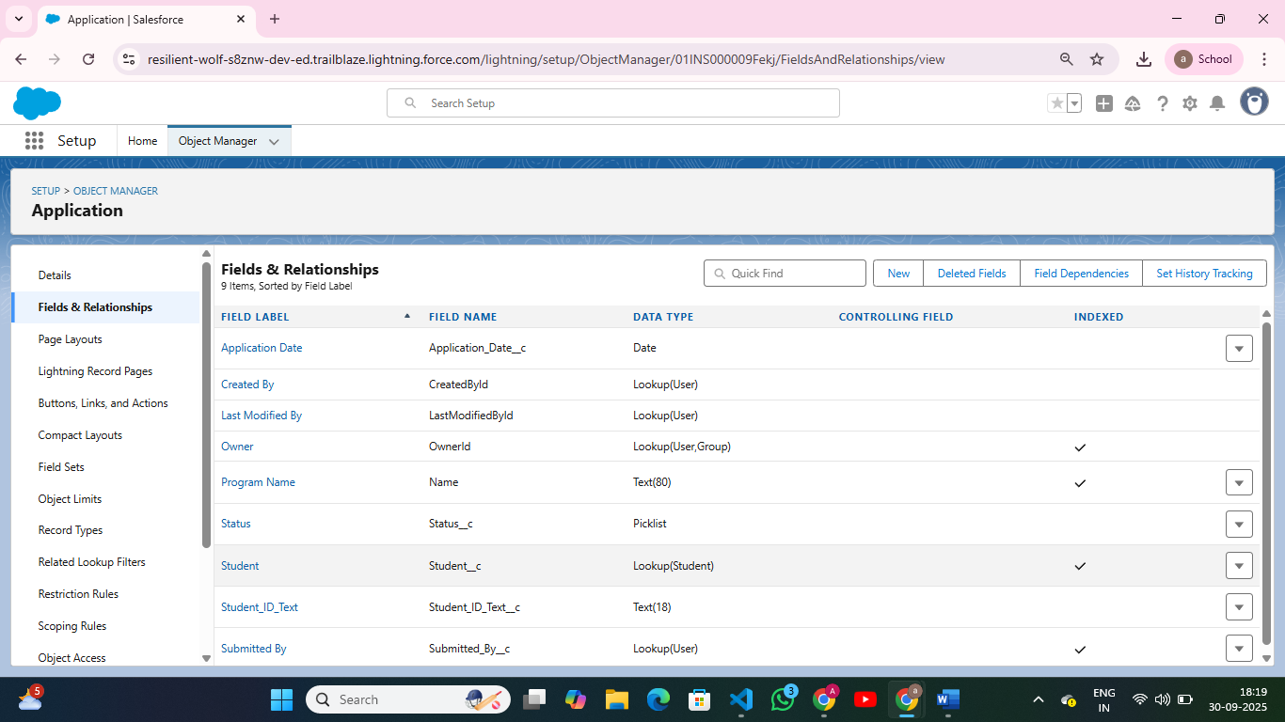

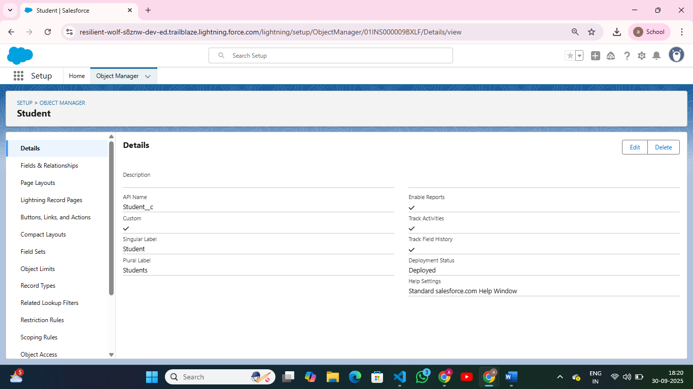

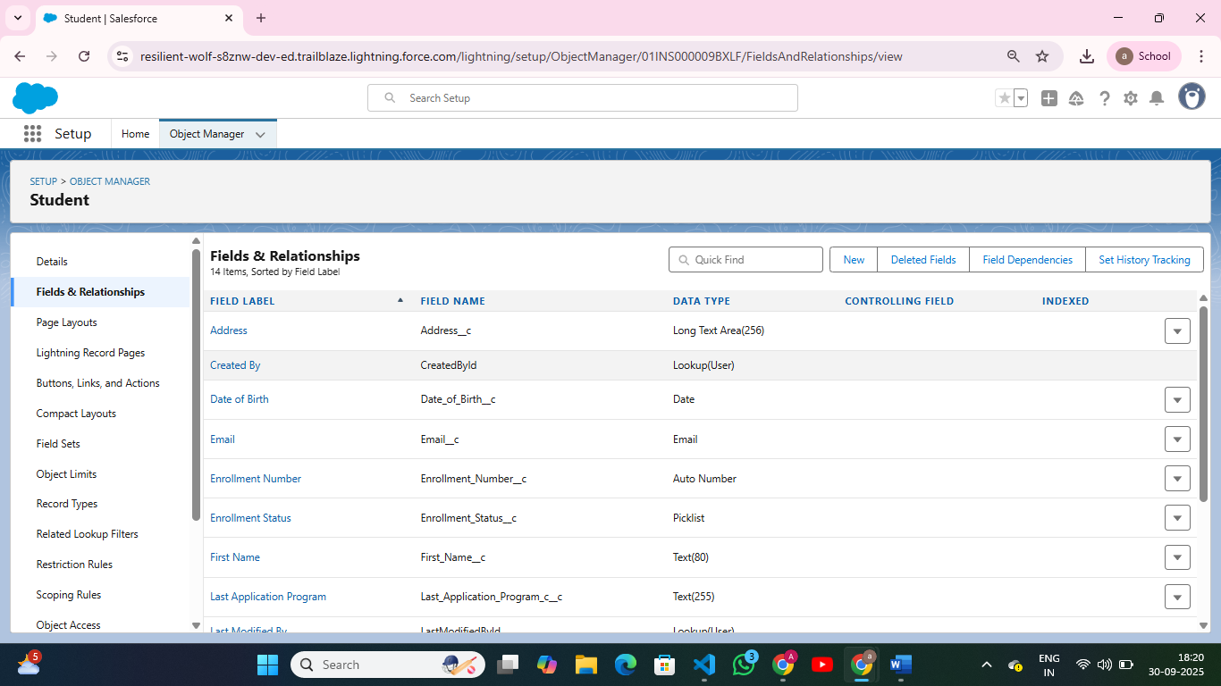

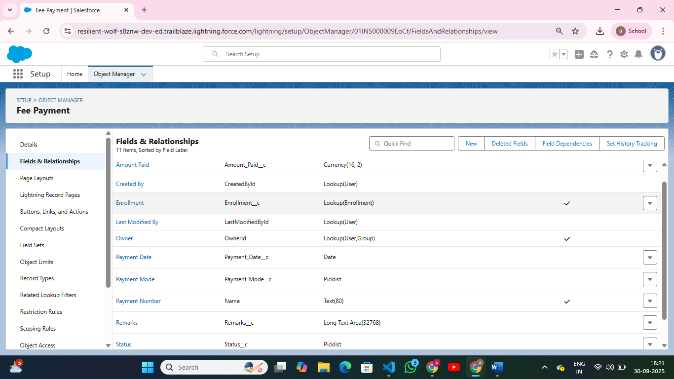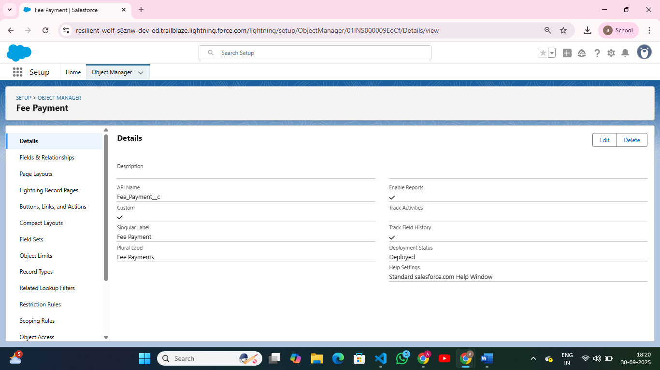

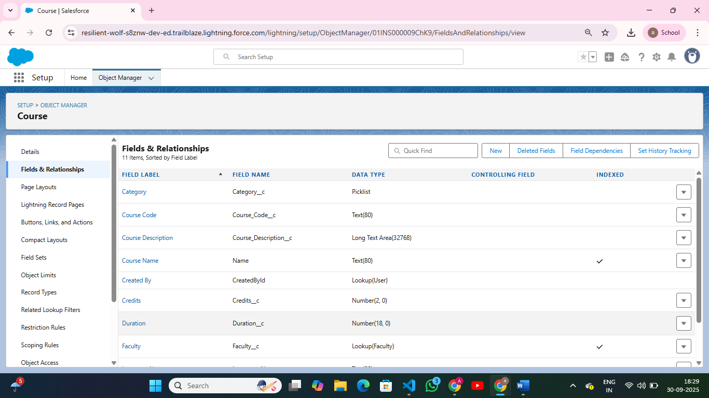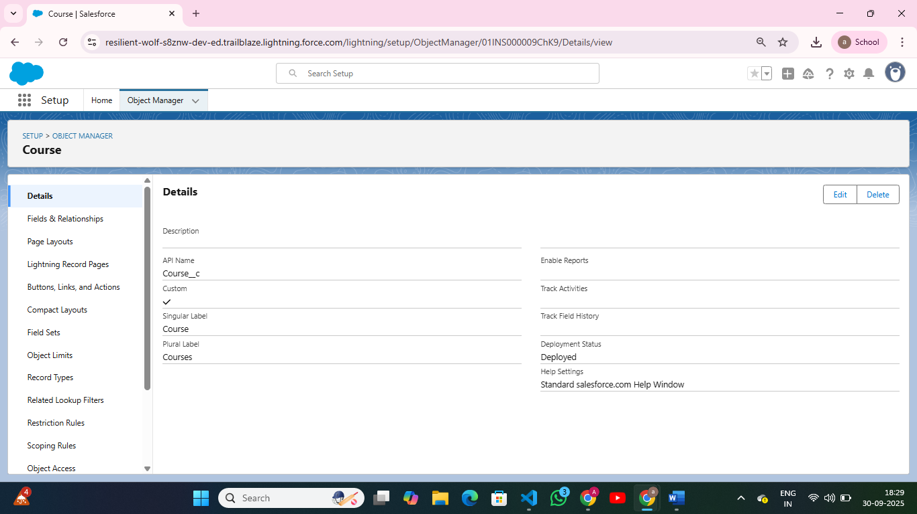

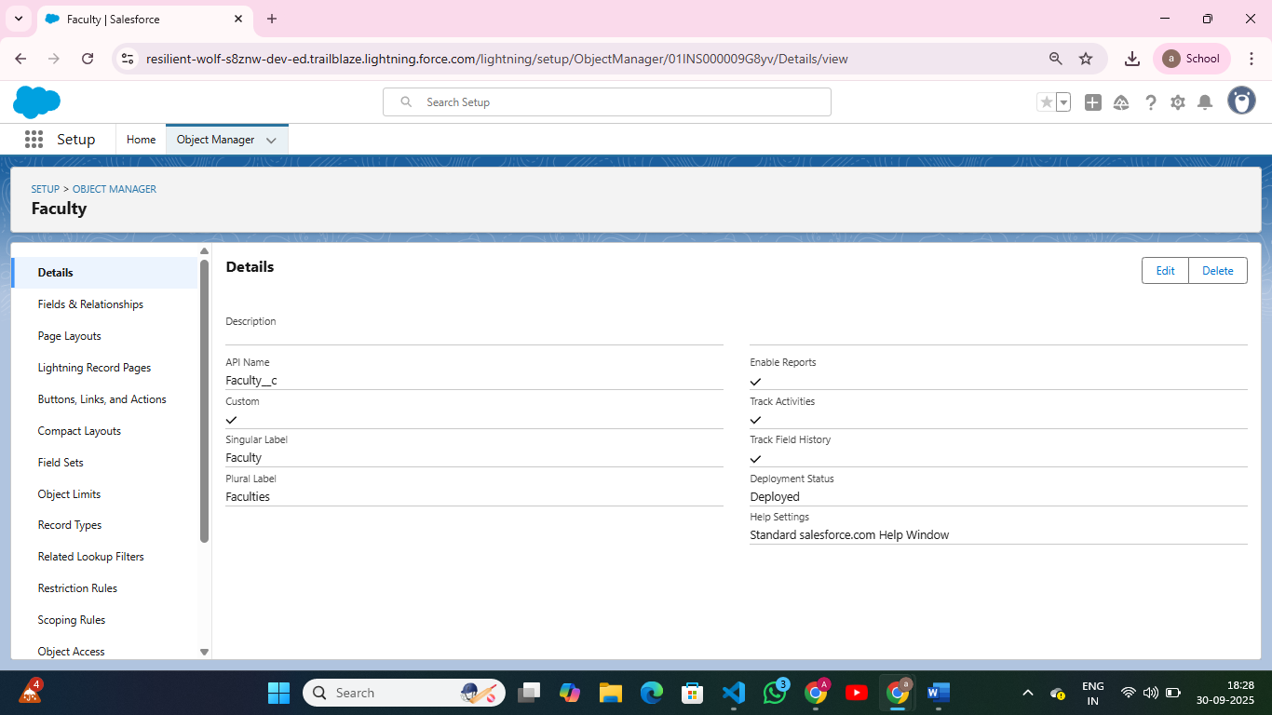

**Page Layouts:**

Setup → Object Manager → Select Object → Page Layouts → Edit/Add Fields → Arrange Sections.

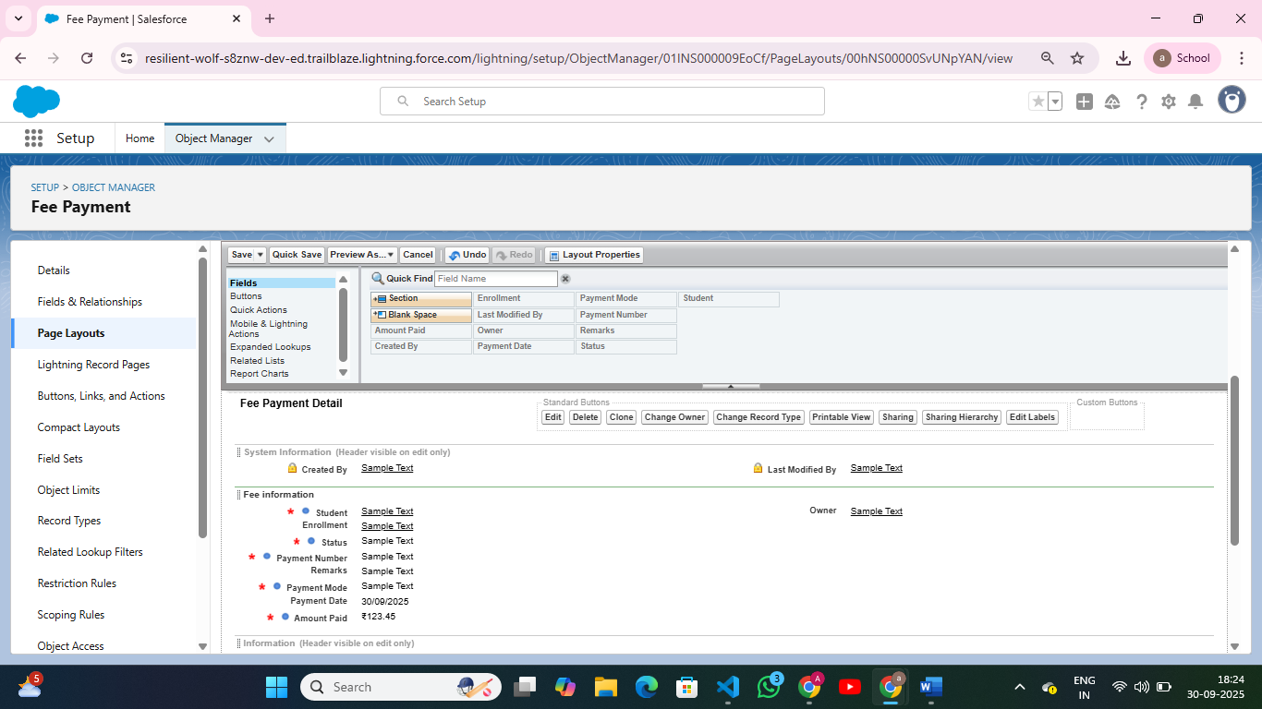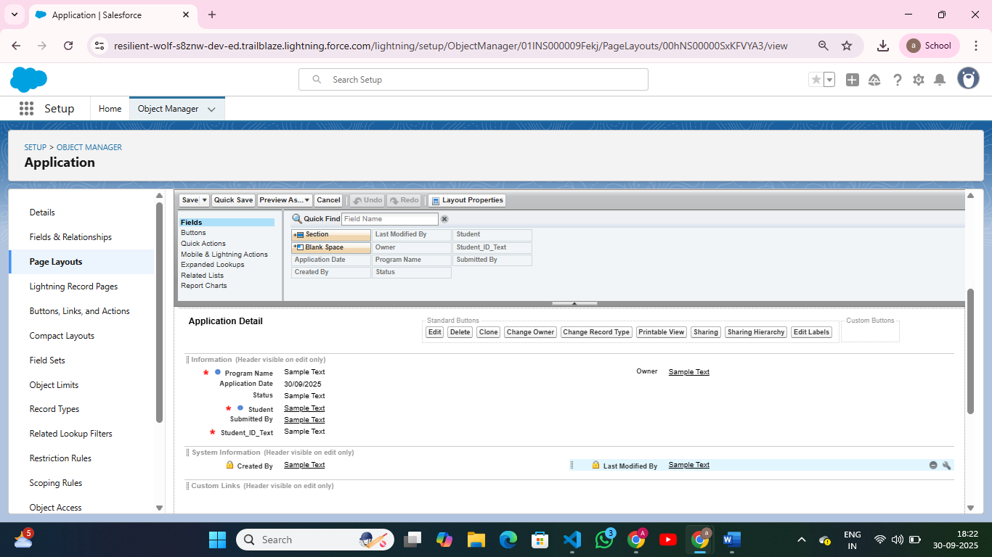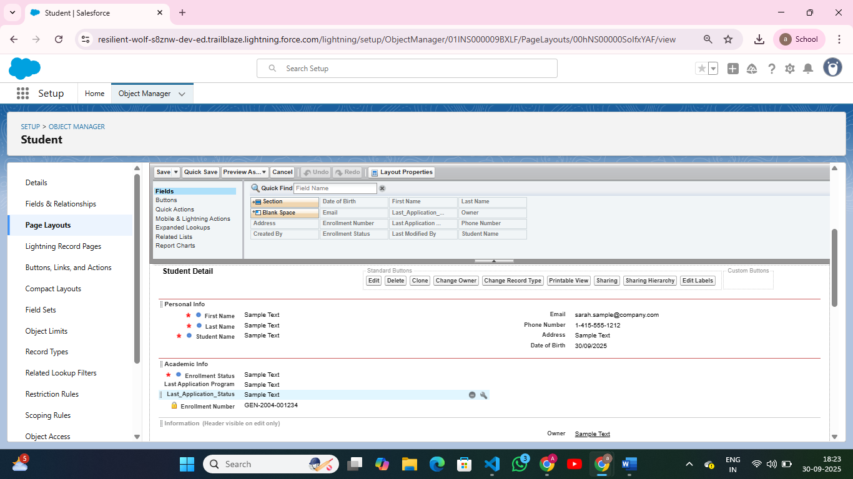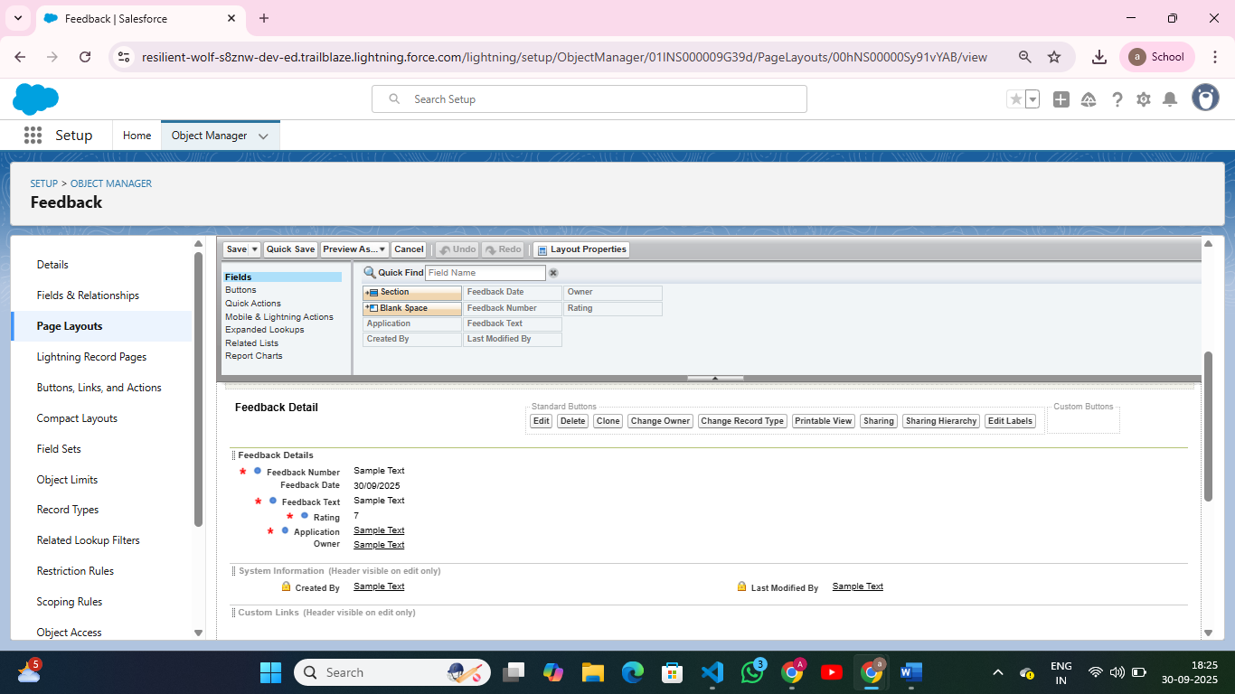

**Compact Layouts**  
Setup → Object Manager → Select Object → Compact Layouts → New → Add Key Fields (*Name, Status, Program*).  
Assign Compact Layout to *Primary Compact Layout*.

**Schema Builder**  
Setup → Schema Builder → Drag Objects → View Relationships between Standard & Custom Objects.

Example: Student ↔ Application (Lookup Relationship).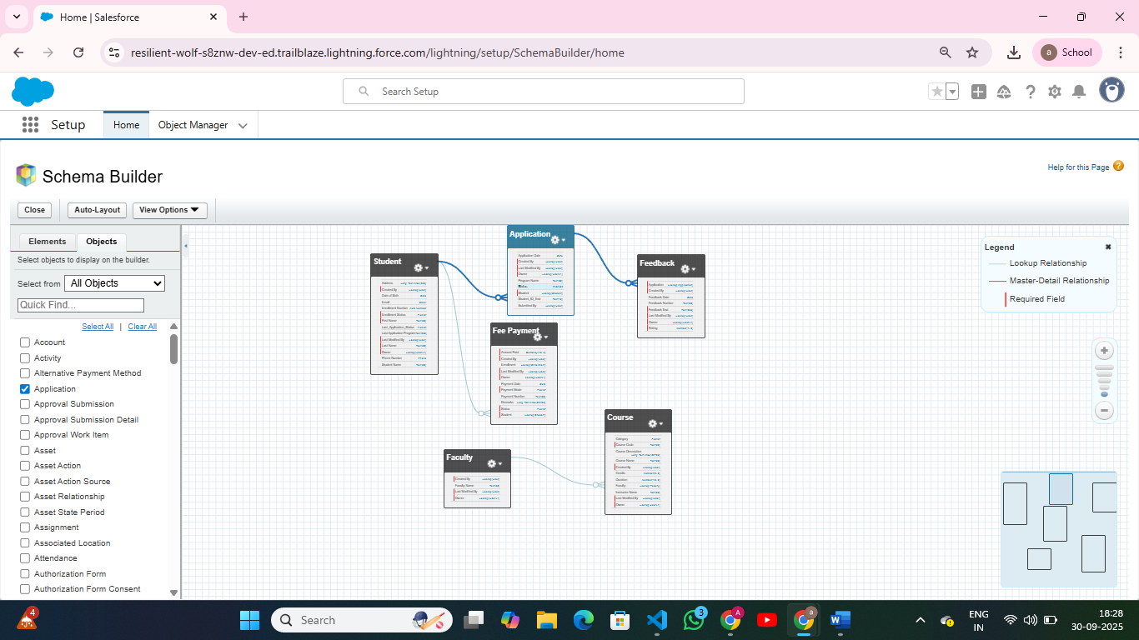

**Lookup vs Master-Detail vs Hierarchical Relationships**

* **Lookup Relationship** → Loose connection (optional, no dependency).
* **Master-Detail Relationship** → Strong dependency (child record deleted if parent is deleted).
* **Hierarchical Relationship** → Available only on User object to represent reporting structure.

Setup → Object Manager → [Select Object] → Fields & Relationships → New → Relationship Field.

**Junction Objects**

Setup → Object Manager → Custom Object → Fields → New → Master-Detail → Select Parent Object.